All staff, volunteers, and committee members of the Houghton Regis Memorial Hall will strive to avoid any conflict of interest between the interests of the Hall on the one hand, and personal, professional, and business interests on the other. This includes avoiding actual conflicts of interest as well as the perception of conflicts of interest.

The purposes of this policy is to protect the integrity of the Committee’s decision-making process, to enable our users to have confidence in our integrity, and to protect the integrity and reputation of volunteers, staff and committee members.

Examples of conflicts of interest include:

1. A committee member who is also a user who must decide whether fees from other users should be increased.
2. A committee member who is related to a member of staff and there is decision to be taken on staff pay and/or conditions.
3. A committee member who is also on the committee of another organisation that may be competing for the same funding.
4. A committee member who has shares in a business that may be awarded a contract to do work or provide services for the Hall.

Upon appointment each committee member will make a full, written disclosure of interests, such as relationships, and posts held, that could potentially result in a conflict of interest. This written disclosure will be kept on file and will be updated as appropriate.

In the course of meetings or activities, committee members must disclose any interests in a transaction or decision where there may be a conflict between the Hall’s best interests and the committee member(s) best interests or a conflict between the best interests of more than one organisation that the committee member(s) is involved with.

* After disclosure, committee member(s) should be made aware and understand that he/she/they will be asked to leave the room for the discussion and **will not be able to take part in the decision.**

Any such disclosure and the subsequent actions taken will be noted in the minutes.

**Disciplinary Consequences**

In cases when a conflict of interest is deliberately concealed or when a solution cannot be found, disciplinary action may be invoked up to and including termination.

This policy is meant to supplement good judgment, and staff, volunteers and committee members should respect its perspective as well as its wording.

Signed: 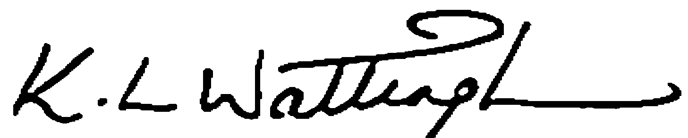 Print Name: ___KEN WATTINGHAM___

Date: ______14TH MAY 2024_________

*Approved by the Chairperson (Board of Trustees) on __________________ (date)*

**Declaration of Interests Statement**

Name: …………………………………….

I have read and understool the Houghton Regis Memorial Hall’s Policy No. 004 relating to Declaration / Conflict of Interest and declare the following:-

I declare a conflict of interest in:

1. ……………………………………………………………………………………………………

……………………………………………………………………………………………………

……………………………………………………………………………………………………

……………………………………………………………………………………………………

1. ……………………………………………………………………………………………………

……………………………………………………………………………………………………

……………………………………………………………………………………………………

……………………………………………………………………………………………………

1. ……………………………………………………………………………………………………

……………………………………………………………………………………………………

……………………………………………………………………………………………………

……………………………………………………………………………………………………

1. ……………………………………………………………………………………………………

……………………………………………………………………………………………………

……………………………………………………………………………………………………

……………………………………………………………………………………………………

1. ……………………………………………………………………………………………………

……………………………………………………………………………………………………

……………………………………………………………………………………………………

……………………………………………………………………………………………………

Signed:  Print Name: ___KEN WATTINGHAM___

I have no other conflicts to declare as of: Date: 14TH MAY 2024